1Objectives 2
2Scope 2
2.1. Mandated Time Constraints 2
3. Outstanding Issues 2
4. Assumptions 2
5. Approvals 3
6. Requirements Notes/Legends 3
7. Component or Subsystem Description 4
7.1. Summary 4
8. Requirements 6
9. Application Functionality 6
9.1. Write Off document requirements 6
9.2. Ledger Entries for Write Offs 9
9.2.1. Overdue Payment Process and Manually Created Write Off Documents 9
9.2.2. Recovered Payment 9
9.3. Template Behavior 9
9.4. Output 10
9.5. Software Interface 10
9.6. Documentation 10
10. System Implementation & Development Requirements 10
10.1. Development Requirement 10
10.2. Business Requirements 10
10.3. Cost 10
10.3.1. Relationship to future products 10
10.3.2. Preliminary estimated release date 10
11. Acceptance Criteria 10
7. Change Log 11

Objectives
This project aims to develop a desk fan for temperature control in an office cubicle. Developing the desk fan is motivated as a sample project for the course of System Design for IT Convergence. The desk fan is expected to sense the ambient temperature and to automatically run the motor of the fan to adjust the temperature. ……………………………………………………………………

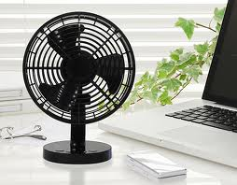
<Add an illustrative figure displaying the expected final product >

This document is produced prior to detailed design and development of the application. It will be used by the design team as the baseline for establishing systems design and ultimately the development of the system.

Scope
The desk fan is expected to cover the area of 3.3 m2. The team is supposed to develop the desk fan controller, the software of the controller, and the sensing and the actuating devices of the desk fan. The desk fan in our scope will exclude the power source and the computer based control of the fan. Rather, the android device level control will be the main focus…………………………………………………………………

<Add an illustrative figure showing the scope of the project>

Mandated Time Constraints
The important dates of this project are in the followings.
- Initial project proposal: Mar 22
- Project proposal acceptance: Mar 27
- Evaluation at the design stage: Week of Apr 10
- Evaluation at the mid-term stage: Week of May 15
- Evaluation at the final-term stage: Week of Jun 26:

Outstanding Issues
None to date

Assumptions
The following are assumptions made in this design:
- The room temperature is expected to be from 10 degree Celsius to 30 degrees Celsius.
- The desk fan is expected to operate with the android power source.
- The room temperature would not change drastically (less than 5 degrees in a minute)
- The desk fan is expected to adjust the temperature within 10 mins.
- The desk fan is expected to be durable even with free falling with 1 meter height.

Approvals

ROLE | NAME | SIGNATURE | DATE
Request Manager | Il-Chul Moon, Course Instructor
Request Stakeholder | Team member 1
Request Stakeholder | Team member 2
Request Stakeholder | Team member 3
Client Services Contact | Team Leader

Requirements Notes/Legends

Priority of data in field:
R | Required
O | Optional
SM | System Maintained (value cannot be changed)
C | Conditionally required

Component or Subsystem Description

Summary

The use case and the expected functions of the desk fan is illustrated in the below use case diagram… ……………………………………………………………………

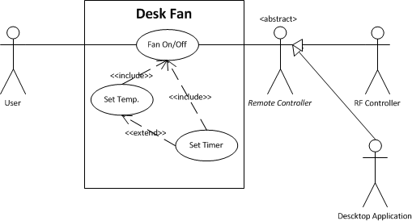

Requirements
The following applies to all processes within this document.

Level: Primary or sub function
Pre-condition: Process is initiated.
Success End Condition: Process is approved by initiator and routes for approval.
Failed End Condition: The process is disapproved. System provides messages regarding the failed results.
Primary Users: The Write Off document will primarily be system generated as a by-product of the Overdue Receivable Management and Recovered Payment processes. The manual creation of the Write Off document is expected to be the exception.
Security: The Write Off document will be restricted to users in the DaFISAR workgroup and that of the C.O. Collections workgroup.

Application Functionality

Fan On/Off requirements
The fan on/off functions will be implemented at the android level with a graphical user interface. The below illustration shows a potential UI design of the function. There should be one toggling button on the UI that reflects the activation of the desk fan in the real time……………….
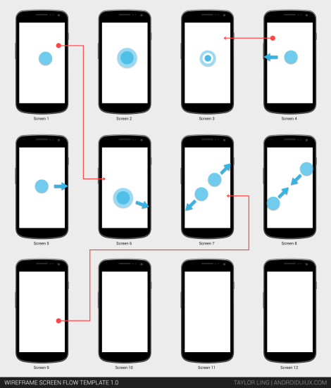

No. |  | Fieldname | Length | R/O/  SM/C | Requirement | Description / Edit
9.1. | 1 | Fan On/Off Button |  | R | Controls the fan on/off  Show  If Fan RPM > 0, then show On  Else show Off | Toggle Button
9.1. | 2 | Fan Current RPM |  | SM | Show the current RPM……………………………………………………… | Read-only field.
9.1. | 3 | Fan Max RPM |  | O | Allow to set the max RPM …………………………………………………………………………………………………. | Editable Field

System Implementation & Development Requirements

Development Requirement

No. |  | Contract | Requirement | V&V Method
10.1. | 1 | - | Create a new document type for the write off document, ‘ARWO’. | User Acceptance

Cost

No. |  | System  Component | Required  Components | Rational | Cost
10.2. | 1 | Fan Sensor/Actuator | Motor | Need to run the fan | 10,000 KRW
10.2. | 2
10.2. | 3
10.2. | 4

Acceptance Criteria

- All requirements implemented and the unit-test will be reported
- The fan operation will be monitored more than an hour, and the fan should operate as contracted.
- ……………………………

Change Log
Date | Source | Author | Change
2013/03/11 | Course Preparation | Il-Chul Moon | Initial template development

